Angry Balloon Activity
What makes angry balloon pop?
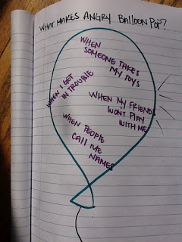
How to let anger go…
1. Blow up a balloon
2. While holding the balloon, talk to your client about the balloon representing their anger (or anxiety, etc.) and brainstorm with them what they think happens when those feelings build up.
3. Now the fun part! Either pop the balloon, or let go of the balloon. Talk about behaviors associated when you let anger build up- tantrums, screaming, calling names, etc.
4. Blow up a balloon
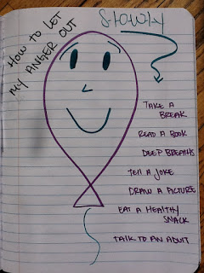
5. While holding the balloon, talk to your client about letting the anger in the balloon out slowly. Review coping skills and anger management techniques while letting the air out of the balloon slowly. Help them understand the difference this made to the way the balloon did not pop or deflate and fly around, comparing this to how their behaviors would change.

